IOAI 2025 Individual Contest Day 1
Team Leader's Translation Version

Team Leaders must complete the form below, even if they don’t need translated documents.
Country Or Region | RWANDA
Number of Team Members  （sample papers will be duplicated according to the number） | 4
How many pages in total  (cover pages included) | 23

IOAI2025 On Site Stage: Radar
Icyitonderwa: Nyamuneka "injira" mu irushanwa mbere. Hanyuma, ushobora gushyira dataset kuri GPU. Bitabaye ibyo, notebook ishobora guhura n'ikibazo kuko idashobora kubona dataset kugeza winjiye mu irushanwa.

- Ibisobanuro by'Ikibazo
Radar ni ikoranabuhanga ry'ingenzi mu itumanaho ridakoresha insinga, rikoreshwa cyane nko mu modoka zitwara. Ubusanzwe rigizwe na antene yohereza ibimenyetso byihariye ikanakira uko bigaruka bivuye ku bintu biri mu bidukikije. Mu gusesengura ibyo bimenyetso, sisitemu imenya icyerekezo, intera, n'umuvuduko w'ibintu by'intego.
Mu by'ukuri, gusesengura ibimenyetso bya radar biragoye kubera urusaku n'ibigaruka bivuye ku bintu bitari intego mu bidukikije. Urugero, mu gihe wageragezaga kumenya abanyamaguru, radar ishobora no kwakira ibigaruka bivuye ku biti cyangwa ibindi bintu birinyuma aho, ibyo bikaba bishobora kugabanya accuracy yawe. Inshingano yawe ni ugukoresha AI mu gusesengura ibimenyetso byakiriwe na radar no kumenya niba hari umuntu muri buri mwanya.
Muri iki gikorwa, turatanga dataset yigeragezwa rya radar mu nzu, kandi intego yawe ni ugukora model ikora radar semantic segmentation.

2. Dataset
Mu gupima ibintu bikikije radar, hakoreshwa ibipimo by'ingenzi bikurikira:
Uburebure (Range): Intera igororotse hagati ya radar n'ikintu.
Icyerekezo (Azimuth): Inguni itambitse (ibumoso-iburyo) hagati ya radar n'ikintu.
Ubuhagarike (Elevation): Inguni ihagaritse (hejuru-hasi) y'ikintu ugereranyije na radar.
Umuvuduko (Velocity): Umuvuduko ikintu kigenderaho cyegera cyangwa kigenda kiva kuri radar.
Amakuru ya radar asesengurwa muri heatmaps zitandukanye, buri imwe ikubiyemo imbaraga z'ikimenyetso cyakiriwe mu myanya n'ibyerekezo bitandukanye.
- Static heatmaps zerekana cyane reflections zibintu bihagaze hamwe.
- Dynamic heatmaps Zerekana impinduka ziterwa n'ibintu bigenda.
Iyo nta kintu kiri ahantu runaka, signal iba igizwe ahanini n'urusaku rwibintu biri inyuma aho kandi ntambaraga ifite. Ibinyuranye n'ibyo, ibigaruka bivuye ku kintu byongera imbaraga za signal, bigatuma ikintu gishobora kumenyekana.
Urugero, static heatmap yerekana imbaraga z'ikimenyetso mu ntera zitandukanye (range) n'inguni zitambitse (azimuth), ahanini bigarurwa n'ibintu bihagaze..
Buri rugero muri dataset rubitswe muri dosiye ya .mat.pt nka tensor ifite imiterere ya 7 * 50 * 181, aho:
- 7 ari umubare wa heatmaps (6 heatmaps + 1 semantic label maps),
- 50 yerekana ibice by'intera (distance)
- 181 yerekana ibice by'inguni cyangwa umuvuduko, bikubiyemo inguni kuva kuri -90° kugeza kuri +90° haba mu gice gitambitse cyangwa gihagaritse. Ushobora gufata ko ibice by'umuvuduko na byo byahinduwe kuva kuri -90° kugeza kuri +90° kugira ngo bigaragare neza.
- buri intensity ya heatmap ihindurwa kuri [0, 1], byerekana imbaraga z'ikimenyetso cyakiriwe.
The 6 heatmaps are structured as follows:
- Index 0: heatmap idahinduka y’intera n’icyerekezo
- Index 1: heatmap ihinduka y’intera n’icyerekezo
- Index 2: heatmap idahinduka y’intera n’ubuhagarike
- Index 3: heatmap ihinduka y’intera n’ubuhagarike
- Index 4: heatmap idahinduka y’intera n’umuvuduko
- Index 5: heatmap ihinduka y’intera n’umuvuduko
Index zose muri heatmap zakorewe normalization, bityo nta unit nconversion ikenewe.
heatmap kuri index 6 ni semantic label map, ibitswe mu buryo bw’intera n’icyerekezo.The map at Index 6 is the semantic label map, stored in range-azimuth format.
- -1: Background (no target)
- 0: Suitcase
- 1: Chair
- 2: Human
- 3: Wall
Uku niko visualization dataset igaragara muri training set:
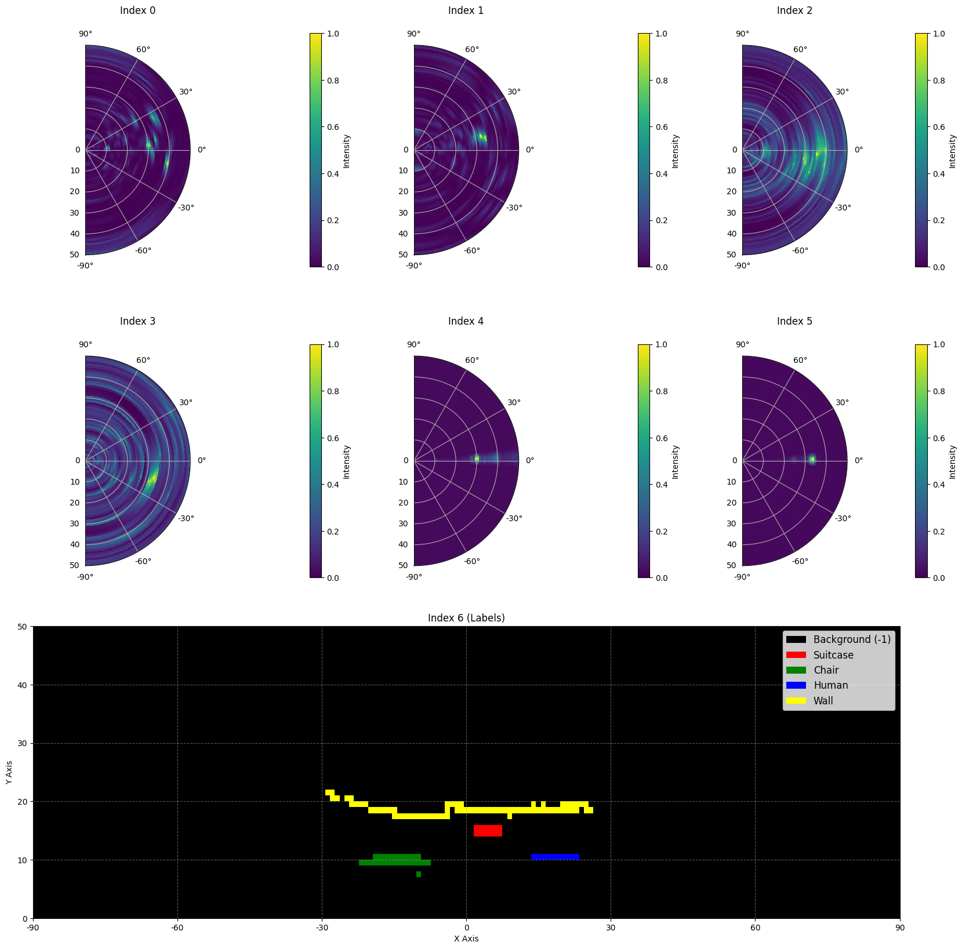
Hano hari igice cy'icyitegererezo kivuye muri dataset:
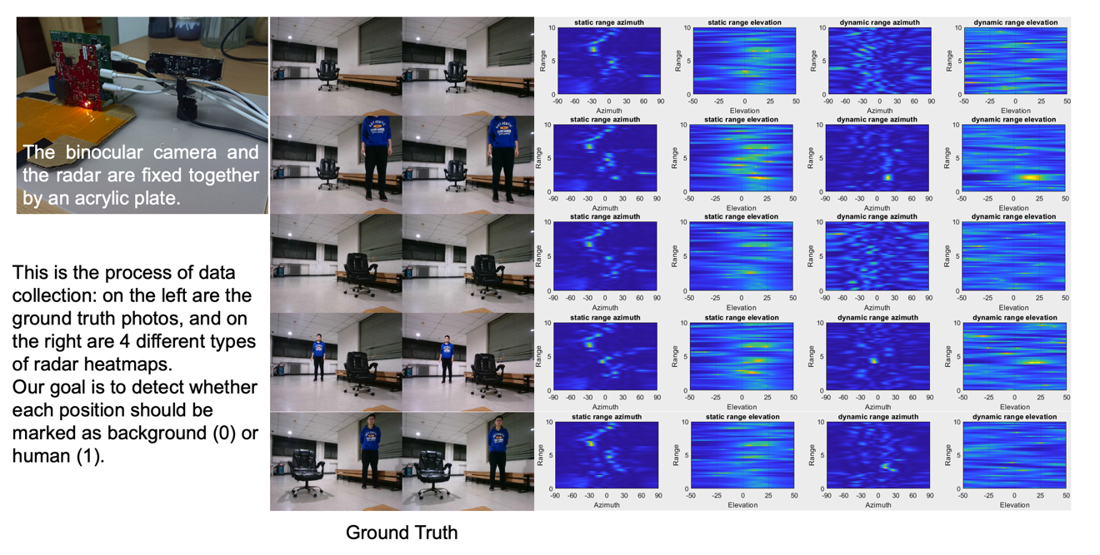

Ingano y'amakuru: ingero 1800 muri training set, ningero 500 muri validation set, n'ingero 500 muri test set.
3. Inshingano

Inshingano yawe ni ugukora model ifata heatmaps esheshatu zambere (index 0 kugeza 5) nka input, iga predictinga semantic label map iri Kuri index ya 6. Intego ni ukumenya neza icyo intego ari cyo (-1 kugeza 3) muri buri location aho radar iri kureba
.
- Ibyinjira: Tensor ifite imiterere ya 6 *50*181, yerekana heatmap esheshatu
2. Ibisohoka: Tensor ifite imiterere ya 50*181, yerekana ikarita y'ibisobanuro y'intego.
4. Submission

Nyamuneka tanga dosiye yitwa submission.ipynb. Ibisohoka ni dosiye ya zip yitwa "submission.zip", ikubiyemo imbonerahamwe ebyiri submission_val.csv na submission_test.csv zihuye n'ibisubizo by'igereranya ry'ibyegeranyo byo kugenzura n'ibyegeranyo by'ibizamini.
Icyitonderwa: Imbonerahamwe isohoka igomba kugira umutwe, amakuru ari mu mbonerahamwe si amakuru nyayo yakemutse, akoreshwa gusa nk'urugero rw'uburyo bwo gutanga.

filename | pixel_0 | pixel_1 | ... | pixel_9049
1.mat.pt | -1 | -1 | ... | -1
... | ... | ... | ... | ...

5. Amanota
Amanota ashingiye ku kuri kwo kumenya ibisobanuro. Kumenya neza ingingo z'intego bihabwa agaciro kurusha kumenya neza ingingo z'ibirinyuma aho.
Amabwiriza yo gutanga amanota:
Buri pixel y'imbago imenyekanye neza ihabwa inota 1.
Buri pixel itari iy'imbago imenyekanye neza ihabwa amanota 50.
Amanota ya nyuma ahindurwa ku manota 0-1 hagereranywa n'amanota menshi ashoboka.

Formule:
：
$$Score=\frac{\left|C_{0,correct}\right|×1+\left|C_{1,correct}\right|×bonus}{\left|C_{0}\right|×1+\left|C_{1}\right|×bonus}$$
aho:
$$\begin{matrix}I & =\{1,2,…,50×181\} \\ C_{0} & =\{i∈I∣y_{i}=-1\} \\ C_{1} & =\{i∈I∣y_{i}≠-1\} \\ C_{0,correct} & =\{i∈C_{0}∣p_{i}=y_{i}\} \\ C_{1,correct} & =\{i∈C_{1}∣p_{i}=y_{i}\} \\ & \end{matrix}$$

Erugero
kuri 3x3 heatmap, ufate ko Ground Truth is
$$\left[\begin{matrix}-1 & -1 & -1 \\ 1 & 2 & 3 \\ -1 & -1 & -1\end{matrix}\right]$$
Igisubizo wamenye ni
$$\left[\begin{matrix}-1 & 1 & -1 \\ -1 & 2 & -1 \\ -1 & 3 & -1\end{matrix}\right]$$
Hanyuma hari -1 enye zamenyekanye neza na 2 imwe yamenyekanye neza. Amanota yawe ni 4 + 50 = 54. Amanota menshi ashoboka ni 6 + 50 * 3 = 156, ni ukuvuga amanota y'ibice bitandatu by'imbago n'ibice bitatu bitari iby'imbago. Amanota yawe yahinduwe ni 54 / 156.
$$Score=\frac{4×1+1×50}{6×1+3×50}=0.346$$

6. Baseline and Training Set
- baseline ni baseline.ipynb.
- Dataset iri muri training set.

7. Requirements
Umubare ntarengwa wo gutanga: inshuro 15. Gusa ibitanzwe byemewe (ni ukuvuga ibibona amanota kuri Leaderboard A) ni byo bizabarwa mu mubare ntarengwa wo gutanga.
Amabwiriza y'ibidukikije by'ibizamini: Imashini y'ibizamini izakoresha Notebook yawe mu minota 15. Niba igihe cyo gukora kirenze iminota 15, sisitemu izahagarika ku gahato ikanagarura igisubizo cya "Timeout" cyangwa "Failed".
Gutanga amakuru na moderi: Muri iki gikorwa, abahatana bashobora gutanga gusa Notebook kandi ntibashobora gutanga ibyegeranyo byashyizweho cyangwa dosiye za .pth bakoze. Nyamuneka reba mu nguni yo hejuru iburyo kugira ngo ukureho ibyegeranyo byashyizweho mbere.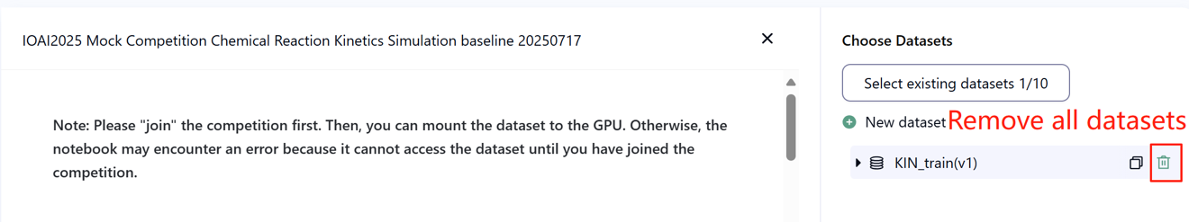
Umuyoboro: Ku cyiciro cyo ku kibuga, imashini y'ibizamini ntishobora guhuzwa na interineti. Mu yandi magambo, amabwiriza yo gukurura nka 'pip' na 'conda' cyangwa kugerageza guhamagara API ntibizakora.
Moderi yatojwe mbere: Moderi iyo ari yo yose yatojwe mbere ishobora gukoreshwa muri iki gikorwa iyo ishobora kwinjizwa neza nta guhuzwa n'umuyoboro no gukurura. Ubu butumwa busobanura ko Bohrium idashobora kwemeza ko moderi zose zatojwe mbere zivanwaho mu ishusho ya Python mu gihe cyo gushyiraho porogaramu, iyo ubonye iz'ingirakamaro, ushobora kuzikoresha.
8. Ibyo kwitondera
Ni ayahe manota yemewe: Abahatana bashobora guhitamo ibisubizo 2 byo gutanga kugira ngo babone amanota (√ - byahiswemo, □ - bitahiswemo). Amanota mbere yo guhuzwa kuri iki gikorwa azagenwa n'amanota yo hejuru kuri Leaderboard B mu bitanzwe bibiri byahiswemo. Ibindi bijyanye no kubara amanota: nyamuneka reba Umugereka w'Amabwiriza n'Imbibi za Platforme ku Irushanwa ku Giti cy'umuntu & GAITE.

Uko wakemura ibitumvikanyweho: Iyo habayeho kutumvikana hagati y'ibisobanuro by'igikorwa n'ibyegeranyo by'imyitozo, ibyegeranyo byo kugenzura n'ibyegeranyo by'ibizamini, ibyegeranyo bizubahirizwa mbere, kandi ibyegeranyo ntibizahindurwa mu gihe cy'irushanwa.
Abahatana bashobora kugera gusa kuri Leaderboard A mu gihe cy'irushanwa kandi ntibashobora kugera kuri Leaderboard B. Amanota ya nyuma azabarwa gusa hashingiwe ku manota yo kuri Leaderboard B.
Amanota yo hejuru yatanzwe na Komite ya Siyansi kuri iki gikorwa ni 0.90 kuri Leaderboard B, aya manota akoreshwa mu guhuza amanota.
Amanota y'icyitegererezo yatanzwe na Komite ya Siyansi kuri iki gikorwa ni 0.67 kuri Leaderboard B, aya manota akoreshwa mu guhuza amanota.

IOAI2025 On Site Stage: Chicken Counting Problem.

Icyitonderwa: Nyamuneka "injira" mu irushanwa mbere. Hanyuma, ushobora gushyira dataset kuri GPU. Bitabaye ibyo, notebook ishobora guhura n'ikibazo kuko idashobora kubona dataset kugeza winjiye mu irushanwa.

1. Ibisobanuro by'Ikibazo
Nkumuyobozi w'itsinda ry'ubushakashatsi bwa AI rikorana n'aborozi b'inkoko za Silkie, ushinzwe gukemura ikibazo gikomeye mu bworozi bwa gakondo bwo mu gasozi. Kubara neza amatungo ni ingenzi haba ku borozi no ku bigo by'ubwishingizi, kuko ibintu nk'ibyorezo by'indwara n'ibitero by'inyamaswa bishobora kugira ingaruka zikomeye ku kigero cyo kubaho kw'izi nkoko mu gihe gito. Mu gihe ubwishingizi bufasha kugabanya ingaruka z'ubuhinzi, uburyo bwo gusaba indishyi busaba kubara neza ibyangiritse mu matungo. Aborozi bawe begereye itsinda ryawe ngo ribafashe gukora uburyo bwo kubara buri kuri kandi bwikorera. Ikibazo kiri imbere y'itsinda ryawe ry'ubushakashatsi ni ugukora moderi yo kubara inkoko za Silkie yanozoye hakoreshejwe uburyo bwo kugereranya ubucucike bushobora gutanga ibibare byizewe byo gushyigikira haba imicungire y'ubworozi n'uburyo bw'ubwishingizi.
Itsinda ryawe rifite uburyo bwo kugera ku gikoresho cyatojwe mbere cyo gukuramo ibiranga amashusho y'inkoko za Silkie, ariko uzakenera gukora no gutoza igice cyo kugereranya ubucucike kugira ngo ukore igisubizo cyuzuye cyo kubara. Inshingano yawe ni ukubakira kuri uyu musingi mu gukora imiterere y'igice cyo gusobanura no gutoza kugira ngo ugere ku bibare by'inkoko byizewe aborozi n'ibigo by'ubwishingizi bashobora kwishingikiriza.
Ishusho ikurikira yerekana ishusho mu byegeranyo, hamwe n'ikwirakwizwa ry'ubucucike nyabwo n'ikwirakwizwa ry'ubucucike ryateganyijwe ryakozwe na moderi y'icyitegererezo. Ubucucike bwose (igiteranyo cy'ubucucike mu bice byose) burerekanwa..
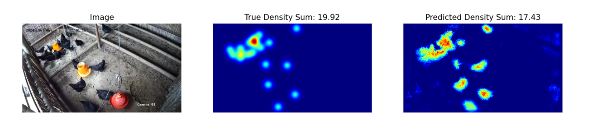

2. Dataset

Ibyegeranyo
Imiterere y'ibyegeranyo by'amashusho y'inkoko za Silkie yatanzwe ni iyi ikurikira:
[AGACE KA KODE]
(1) Aho ibyegeranyo by'imyitozo biherereye: datasets, dosiye ziri muri ubu bubiko zikoreshwa mu kunoza moderi. Harimo ububiko bwa train, bubitsemo ibyegeranyo by'amashusho 100 n'amakarita y'ubucucike ahuye na yo.
(2) Ibyegeranyo byo kugenzura (test_a) n'ibyegeranyo by'ibizamini (test_b): Bizakoreshwa mu gusuzuma amanota kuri Leaderboard A na Leaderboard B. Ntibizashobora kugerwaho n'abahatana. Amanota azabarwa gusa hashingiwe ku manota yo ku byegeranyo by'ibizamini B.
(3) Ingano y'ibyegeranyo:
Ibyegeranyo by'imyitozo: amashusho 100.
Ibyegeranyo byo kugenzura: amashusho 100.
Ibyegeranyo by'ibizamini: amashusho 100.
(4) Ibyegeranyo byo kugenzura (test_a) n'ibyegeranyo by'ibizamini (test_b) ntibigaragara.
(5) Kubera imbibi z'ibikoresho byo kubara, amakarita y'ubucucike y'imyitozo ahindurirwa imiterere kuri [FORMULE]. ICYITONDERWA ikarita y'ubucucike isohoka ishobora gufatwa nk'imbonerahamwe y'imibare nyayo ya 2D ifite imiterere ya [FORMULE], igiteranyo cy'indangagaciro zose z'imbonerahamwe ni umubare w'inkoko.
- Inshingano
Inshingano yawe ni ugutoza moderi yawe bwite ukoresheje amakuru y'imyitozo kugira ngo uteganye amakarita y'ubucucike, bityo ugere ku ntego yo kubara inkoko.
Ushobora kwagura no kunoza moderi yatojwe mbere yatanzwe kugira ngo wongere ukuri kwayo mu guteganya umubare. Moderi yatojwe mbere ya base.pth ikubiyemo gusa ibiro by'ibice bine bya mbere bya moderi (moderi yo gukuramo ibiranga), kandi imikorere ya load_pretrained_weights_partial muri kode y'icyitegererezo ishobora gukoreshwa mu gushyira ibyo biro by'igice muri moderi yawe. Ushobora gukora igice cyo gusobanura ubucucike (Density Decoder) ukagihuza na moderi yo gukuramo ibiranga yatojwe mbere kugira ngo ukore moderi yuzuye yo guteganya amakuru.
[AGACE KA KODE]
Ushobora no gukora moderi yawe bwite udakoresheje moderi yatojwe mbere twatanze.
Iki gikorwa ni ikomeza ry'Iteganyamiterere ry'Ikirere ry'Icyogajuru. Twibutse ko UNET yuzura byoroshye ububiko bwa GPU nta buhanga bw'ibiranga. Hanyuma, ubutumwa bw'ikosa ry'ububiko bwa GPU buzagaragara.
Nyamuneka kurikiza aya mabwiriza kugira ngo ubone amanota neza:
(1) Moderi yawe igomba gusohora ikarita y'ubucucike yateganyijwe.
(2) Kubera imbibi z'ibikoresho byo kubara, ikarita yawe y'ubucucike isohoka igomba guhindurirwa imiterere kuri [FORMULE]. Iyi ni na yo miterere y'amakarita y'ubucucike y'intego yatanzwe mu byegeranyo by'imyitozo.

4. Gutanga
Nyamuneka tanga dosiye ya submission.ipynb ikubiyemo ibi bikurikira:
(1) Kode y'Imyitozo
Shyiramo uruhererekane rwose rw'imyitozo.
(2) Kode yo Gusuzuma
Suzuma moderi yawe ku byegeranyo byo kugenzura no ku byegeranyo by'ibizamini. Reba baseline.ipynb kugira ngo umenye uko wagera kuri ibyo byegeranyo ukoresheje DATA_PATH y'ibanga.
Ibisohoka bigomba kubikwa nka submission.npz. Igomba kuba dosiye ya npz yemewe ikubiyemo imbonerahamwe ebyiri pred_a na pred_b, buri imwe ifite imiterere ya 100x1x180x320 (Inyandiko yo gusuzuma izanakira ibiteganyijwe bifite imiterere ya 100x180x320, niba uhisemo kugabanya igice cy'umuyoboro).
Igisubizo cyose kidahuye n'ingano yatanzwe kizafatwa nk'ikitemewe, bigatuma habaho amanota yo gusuzuma y'ubusa.
Buri kintu cy'ikarita y'ubucucike kigomba kuba kitari munsi ya zero, bitabaye ibyo bizatuma habaho amanota yo gusuzuma y'ubusa.

5. Amanota
Uzahabwa amanota hashingiwe ku kigereranyo cy'ikosa rigereranywa rya moderi yawe. Ikosa rigereranywa risobanurwa na:
[FORMULE]
aho [FORMULE] ni ubucucike bwose nyabwo bw'icyitegererezo cya i, naho [FORMULE] ni ubucucike bwose bwateganyijwe bw'icyitegererezo cya i.
Amanota yawe ya nyuma mbere yo guhindurwa azabarwa hashingiwe ku kigereranyo cy'ikosa ryawe rigereranywa, ku buryo bukurikira:
[FORMULE]

6. Icyitegererezo & Ibyegeranyo by'Imyitozo
Icyitegererezo kiri muri baseline.ipynb.
Ibyegeranyo by'imyitozo biri mu byegeranyo by'imyitozo.

7. Requirements
Umubare ntarengwa wo gutanga: inshuro 15. Gusa ibitanzwe byemewe (ni ukuvuga ibibona amanota kuri Leaderboard A) ni byo bizabarwa mu mubare ntarengwa wo gutanga.
Amabwiriza y'ibidukikije by'ibizamini: Imashini y'ibizamini izakoresha Notebook yawe mu minota 15. Niba igihe cyo gukora kirenze iminota 15, sisitemu izahagarika ku gahato ikanagarura igisubizo cya "Timeout" cyangwa "Failed".
Gutanga amakuru na moderi: Muri iki gikorwa, abahatana bashobora gutanga gusa Notebook kandi ntibashobora gutanga ibyegeranyo byashyizweho cyangwa dosiye za .pth bakoze. Nyamuneka reba mu nguni yo hejuru iburyo kugira ngo ukureho ibyegeranyo byashyizweho mbere.
Umuyoboro: Ku cyiciro cyo ku kibuga, imashini y'ibizamini ntishobora guhuzwa na interineti. Mu yandi magambo, amabwiriza yo gukurura nka 'pip' na 'conda' cyangwa kugerageza guhamagara API ntibizakora.
Moderi yatojwe mbere: Ushobora gukoresha ibiro byatojwe mbere biri kuri base.pth, ariko si itegeko.
Moderi iyo ari yo yose yatojwe mbere ishobora gukoreshwa muri iki gikorwa iyo ishobora kwinjizwa neza nta guhuzwa n'umuyoboro no gukurura. Ubu butumwa busobanura ko Bohrium idashobora kwemeza ko moderi zose zatojwe mbere zivanwaho mu ishusho ya Python mu gihe cyo gushyiraho porogaramu, iyo ubonye iz'ingirakamaro, ushobora kuzikoresha.


8. Ibyo kwitondera
Ni ayahe manota yemewe: Abahatana bashobora guhitamo ibisubizo 2 byo gutanga kugira ngo babone amanota (√ - byahiswemo, □ - bitahiswemo). Amanota mbere yo guhuzwa kuri iki gikorwa azagenwa n'amanota yo hejuru kuri Leaderboard B mu bitanzwe bibiri byahiswemo. Ibindi bijyanye no kubara amanota: nyamuneka reba Umugereka w'Amabwiriza n'Imbibi za Platforme ku Irushanwa ku Giti cy'umuntu & GAITE


IOAI2025 On Site Stage: Concepts

Note: Please "join" the competition first. Then, you can mount the dataset to the GPU. Otherwise, the notebook may encounter an error because it cannot access the dataset until you have joined the competition.

1. Problem Description






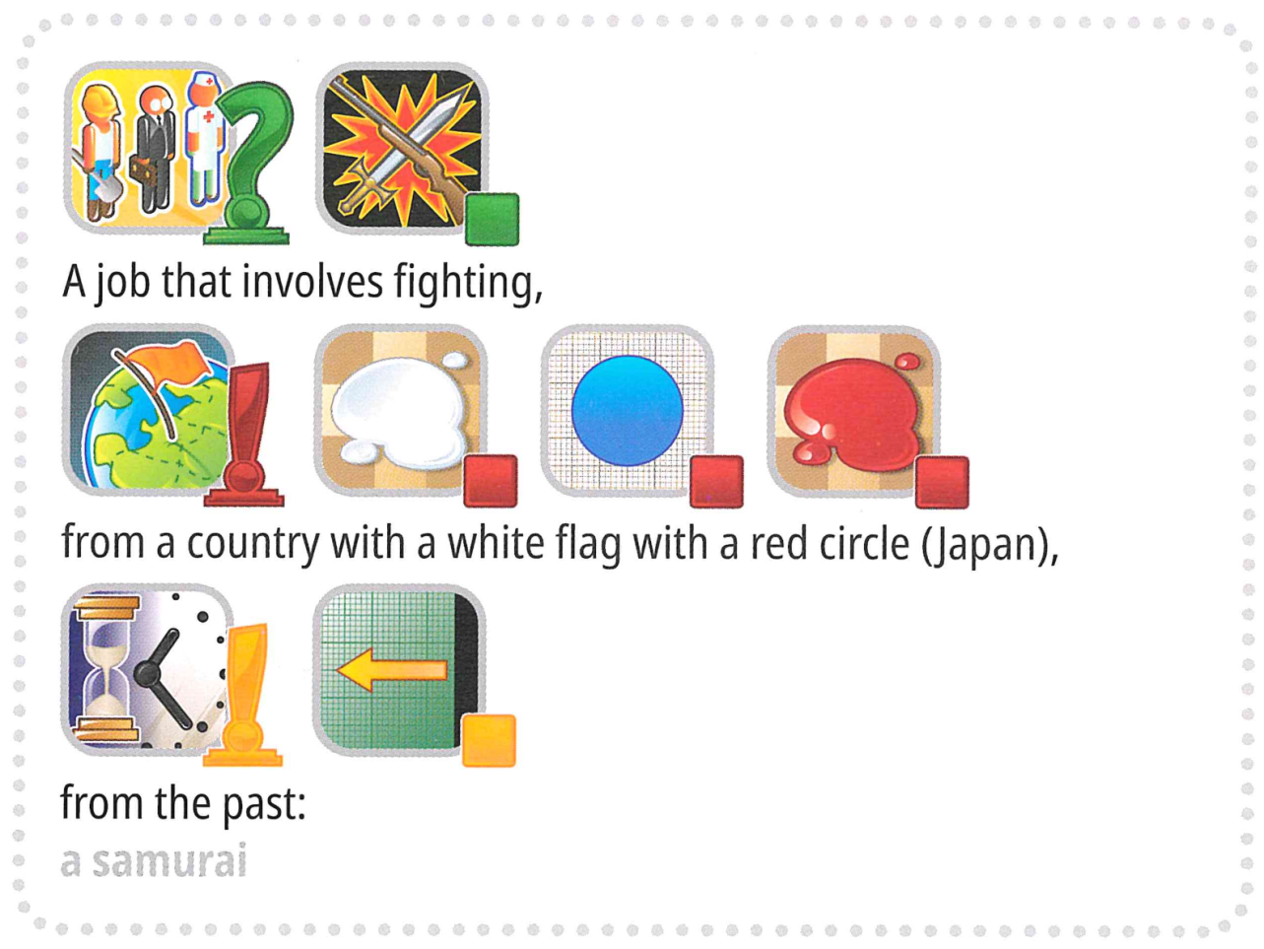

- Ibisobanuro by'Ikibazo
Concepts ni umukino wo gukeka amagambo aho abakinyi batanga ibitekerezo bakoresheje ibishushanyo. Hari inshingano ebyiri: Utanga Ibimenyetso na Ukeka. Bombi abakinyi bafite urutonde rw'ibishushanyo rusangiwe, buri kimwe gifite ibisobanuro bizwi. Hano hari ingero z'ibishushanyo:
[ISHUSHO]
Utanga Ibimenyetso abanza guhitamo ibanga, ni ukuvuga ijambo cyangwa interuro, hanyuma agatanga igisobanuro kuri ryo yerekeza ku rukurikirane rw'ibishushanyo bivuye ku rutonde rusangiwe — kuvuga cyangwa kwandika ntibyemewe.
Ukurikirana kw'ibishushanyo mu gisobanuro gufite ibisobanuro:
Igishushanyo cya mbere ubusanzwe kigaragaza igitekerezo cy'ibanze cy'ibanga.
Ibishushanyo bikurikiraho bitanga ibisobanuro byunganira bifasha gusobanura neza cyangwa kwagura igitekerezo cy'ibanze.
Urugero rwa 1
Igisobanuro gikurikira gishobora gusobanurwa nk'ahantu hakorerwa akazi ko kurwanya umuriro — mu yandi magambo, ikigo cy'abazimyamuriro:
[ISHUSHO]
Niba ukurikirana kw'ibishushanyo guhinduwe, bishobora ahubwo kwerekana akazi ko kurwanya umuriro mu nzu — byerekeza ku muzimyamuriro:
[ISHUSHO]
Urugero rwa 2
Ibishushanyo bishobora kugira ibisobanuro bitandukanye bitewe n'aho biri. Urugero, igishushanyo cy'umutima gishobora kugaragara mu gisobanuro gikurikira, cyerekana igikoresho gikoreshwa n'abaganga mu kumva umutima — stetosikope:
[ISHUSHO]
Igishushanyo kimwe cy'umutima gishobora ahubwo kugaragara mu gisobanuro cyerekana umuntu wo mu ntekerezo uriho kandi apfuye — byerekeza kuri zombi:
[ISHUSHO]
Ku Cyiciro cyo mu Rugo, abahatana bari barakoze porogaramu ya AI iteganya ibisubizo ishingiye ku rukurikirane rw'ibimenyetso. Birashimishije. Ariko, inshuti yawe noneho yaguhaye ikibazo: "Gukeka biroroshye, ariko se ushobora gukora sisitemu ya AI ishobora no gutanga igisobanuro cyiza?"
Mu by'ukuri, bakomeje kukubaza niba ushobora gukora sisitemu ya AI ishobora gutanga igisobanuro cyiza ku buryo indi sisitemu ya AI ishobora gukeka ijambo ryawe ry'ibanze!
Kugira ngo ikibazo kirusheho gushimisha, ubu turakina umukino usanzwe wa Concept. Twibutse ko umukino wacu wa Concept wari worohejwe ku buryo igisobanuro cyashoboraga kuba kigizwe gusa n'urukurikirane rumwe rw'ibimenyetso.
Noneho, ushobora gutanga kugeza ku nkurikirane 4 z'ibimenyetso!
Tukoresheje ibi, dushobora kugaragaza ibitekerezo bigoye neza. Reka turebe urugero rukoresha inkurikirane 3 z'ibimenyetso mu gusobanura samurai:
[ISHUSHO]
Ariko tegera, hari ibindi. Kugira ngo ikibazo kirusheho gushimisha, umukino ubu uzaba urimo amwe mu magambo y'ibanze adasanzwe aboneka mu mukino wa Concept, nk' "Olimpiyade Mpuzamahanga."
Ese witeguye iki kibazo?
[ISHUSHO]
Imiterere Nshya Ishingiye kuri AI: Twasimbuje ukeka w'umuntu Ukeka wa AI. Kugira ngo umukino worohe:
Ijambo ry'intego (label) rizahora rihitanwa mu rutonde rwateguwe mbere (options).
Ibimenyetso bigomba kuba urukurikirane rw'ibimenyetso rwahiswemo gusa mu rutonde ruhamye rw'ibimenyetso 118 by'abakandida.
Amagambo y'ibanze
Kugira ngo habeho kumvikana neza no guhuza, turimo tunonosora amagambo y'ingenzi mu bikoresho byose.
label: Igisubizo cy'intego (cyangwa "ibanga") kigomba kumenyekana.
options: Urutonde rwateguwe mbere rw'abakandida aho labels zose zemewe zihitanwa.
marker: Igishushanyo kigaragaza igitekerezo, hamwe n'ibisobanuro byacyo byanditse.
hints: Urukurikirane rw'ibimenyetso ruhawe ukeka wa AI kugira ngo rumufashe kumenya label.
Inshingano yawe ni gutanga igisobanuro kuri buri label kugira ngo ufasha ukeka wa AI kukimenya. Urugero, iyo label y'intego ari "mikoro", porogaramu yawe ishobora gukora inkurikirane enye z'ibimenyetso nka:
Igisobanuro 1: ["Ikintu-Agasanduku", "Ikoranabuhanga-Kubara", "Umunwa-Uburyohe", "Ugutwi-Ijwi-Kumva", "Igikoresho-Kubaka"]
Igisobanuro 2: ["Umuziki-Indirimbo", "Televiziyo-Porogaramu-Ikiganiro", "Akazi-Umwuga", "Gukoresha - Igikorwa-Gukora - Inshinga-Buto"]
Igisobanuro 3: ["Umukara", "Icyuma", "Plastiki-Reberi", "Silinderi", "Uruziga-Impeta"]
Igisobanuro 4: ["Ukuboko-Ikiganza-Urutoki", "Ibyishimo-Byiza", "Imvugo - Interuro-Kuvuga-Amagambo", "Ubuzima-Umutima-Urukundo"]

2. Dataset
Imiterere y'ibyegeranyo byatanzwe ni iyi ikurikira:
[AGACE KA KODE]
Ibyegeranyo by'imyitozo: dosiye ziri muri ubu bubiko zikoreshwa mu myitozo ya moderi. Harimo:
train/: Ibyegeranyo bya huggingface bifite igice kimwe 'train', gifite ingero 30, buri imwe ikubiyemo:
label: umurongo - ijambo ry'ibanze/igisubizo
options: urukurikirane rw'imirongo - urutonde rw'amahitamo 100 ashoboka
hint_descriptions/: Ibyegeranyo bya huggingface bifite igice kimwe 'train', gifite ibimenyetso 118 n'ibisobanuro byabyo:
ID: int64 - indangamuntu yihariye kuri buri kimenyetso
Description: umurongo - ibisobanuro byanditse by'icyo ikimenyetso gisobanura
image: Ishusho - ishusho igaragara y'ikimenyetso
Ibyegeranyo by'ibizamini: Biherereye kuri [FORMULE]. Ntibizashobora kugerwaho mu gihe cyo gukora kandi bizaboneka gusa mu bidukikije byo gusuzuma:
test_a/: Ibyegeranyo bya huggingface bifite igice kimwe 'test' gikubiyemo ingero 150 zo gusuzuma kuri leaderboard A
test_b/: Ibyegeranyo bya huggingface bifite igice kimwe 'test' gikubiyemo ingero 150 zo gutanga amanota ya nyuma
Ibyegeranyo byombi by'ibizamini bifite imiterere imwe n'ibyegeranyo by'imyitozo (ibice bya label na options)

3. Task
Inshingano yawe ni gutanga igisobanuro kuri buri label kugira ngo ufasha ukeka wa AI kukimenya. Urasabwa gukora porogaramu ifata ibyinjira bibiri:
Umurongo wa label (ibanga ryawe label)
Urutonde rwa options (amahitamo 100 ashoboka kuri ukeka)
Label yemejwe kuba imwe mu mahitamo.
Byongeye, porogaramu izakoresha ibimenyetso by'abakandida byateguwe mbere.
[ISHUSHO]
Iyi porogaramu igomba kugarura urutonde rw'intonde z'imibare kuri buri label, byerekana ibimenyetso (ni ukuvuga inkurikirane z'ibimenyetso). By'umwihariko:
Urutonde rugaruwe rugomba kuba rurimo bitarenze inkurikirane 4.
Buri nkurikirane ishobora kuba irimo kugeza ku mibare 8.
Buri mubare werekana ID y'ikimenyetso mu gisobanuro.
Ibimenyetso byawe bizahabwa ukeka wa AI w'agasanduku k'umukara. Uzabona inota niba ukeka wa AI w'agasanduku k'umukara ashoboye gukeka neza ijambo ryawe ry'ibanga ashingiye ku bimenyetso byawe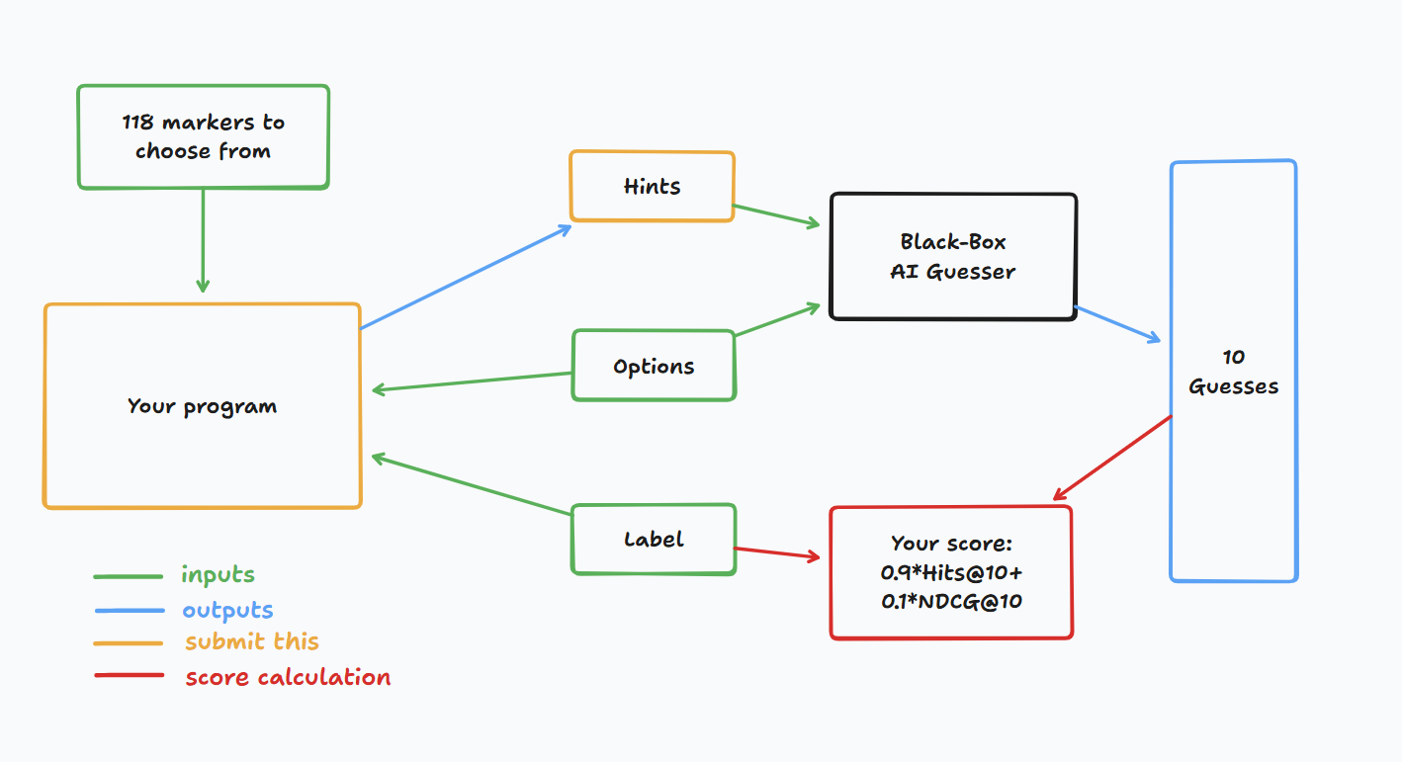

4. Submission
Tanga notebook ikora submission.zip, ikubiyemo clues_a.jsonl na clues_b.jsonl, ibimenyetso bya testset a na b, mu buryo bwa json. Reba notebook y'icyitegererezo kugira ngo umenye uko wakora izo dosiye n'imiterere yihariye ya dosiye za jsonl. Nyamuneka menya neza ko ukurikiza amabwiriza yo kwita amazina no gutunganya.
Abahatana bashobora gutanga dosiye za moderi. Niba batanga dosiye za moderi, abahatana bagomba gukora ibyegeranyo bihuye kuri platforme ya Bohrium. Ibyegeranyo bimwe gusa bishobora gutangwa kuri iki gikorwa, kandi ingano yabyo ntigomba kurenga 2GB. Ibyegeranyo na moderi byashyizweho mbere bizahita bishyirwa ku mashini y'ibizamini, bikuraho gukenera kubishyiraho mu buryo bwa manyeri mu gihe cyo gutanga.

5. Score
Igisobanuro cyawe gisuzumwa hakoreshejwe ibipimo bibiri:
Hits@10 = 1 niba ijambo ry'ibanga riri mu bikekwa 10 bya mbere bya AI, bitabaye ibyo 0.
NDCG@10 (Normalized Discounted Cumulative Gain) Ihemba igisubizo cyiza cyane niba kigaragaye hejuru ku rutonde.
Niba ijambo ry'ibanga riri ku mwanya wa i (1-based):
[FORMULE]
Ingero:
Umwanya wa 1 → 1.00
Umwanya wa 2 → ~0.63
Umwanya wa 4 → ~0.43
Umwanya wa 10 → ~0.29
Amanota ya Nyuma
Amanota yawe ya nyuma azaba igiteranyo cy'byombi, by'umwihariko, azaba 0.9 * Hits@10 + 0.1 * NDCG@10

6. Baseline & Available Tools
Icyitegererezo & Ibikoresho Biboneka
Icyitegererezo kiri muri baseline.ipynb
Ibyegeranyo by'imyitozo na moderi zatojwe mbere biri mu byegeranyo by'imyitoyo
API y'Ukeka wa AI
Ushobora kugera ku mukeka wa AI kugira ngo ukinishe. Reba kode ikurikira kugira ngo umenye uko wagera ku mukeka. Birasabwa gushyiraho uburyo bwo kongera kugerageza kuko hashobora kubaho ibibazo by'umuyoboro. Kugira ngo ubone kode yuzuye, reba baseline.ipynb.
[AGACE KA KODE]
Ingenzi: API y'Ukeka wa AI ntizaboneka ku mashini zo gusuzuma. Mu yandi magambo, NTUGahamagare api muri notebook zawe zo gutanga. Ibi ni ibyo kugira ngo wemeze/utoze moderi yawe ku giti cyawe. Ushobora kongeraho ibiro bya moderi yawe, amakuru y'imyitozo, n'ibindi ukoresheje ibyegeranyo bya Bohrium. Reba igice cy'Ibisabwa.
Ibidukikije
Twashyizeho vllm, sglang na unsloth mu bidukikije byo gusuzuma no kunoza LLM. Byongeye, dutanga uburyo bwo kugera kuri moderi zikurikira za huggingface dukoresheje ibyegeranyo by'imyitozo kuri platforme ya Bohrium:
Moderi zo Gushyiramo
[URUTONDE RW'AMAMODERI]
LLM Ntoya
[URUTONDE RW'AMAMODERI]
Ushobora kureba inyigisho za moderi za huggingface kugira ngo umenye uko wakwinjiza neza izo moderi z'aho.
Uburyo bwo Kugera kuri Proxy ya LLM

Dutanga proxy ya LLM. Reba inyigisho za proxy ya LLM kugira ngo umenye uko wagera kuri proxy. Wibuke ko uzagira inguzanyo ya $10. Twibutse ko utemerewe gukoresha API z'abikorera, kwinjira mu zindi serivisi zo hanze (harimo na huggingface), cyangwa gukoresha ibimenyetso byawe kuri serivisi iyo ari yo yose. Ingenzi: Proxy ya LLM ntizaboneka ku mashini z'ibizamini. Niba notebook watanze igerageje guhamagara api, ntizakora

7. Requirements
Ibisabwa Rusange
Umubare ntarengwa wo gutanga: inshuro 15. Gusa ibitanzwe byemewe (ni ukuvuga ibibona amanota kuri Leaderboard A) ni byo bizabarwa mu mubare ntarengwa wo gutanga.
Amabwiriza y'ibidukikije by'ibizamini: Imashini y'ibizamini izakoresha Notebook yawe mu minota 10. Niba igihe cyo gukora kirenze iminota 10, sisitemu izahagarika ku gahato ikanagarura igisubizo cya "Timeout" cyangwa "Failed".
Gutanga amakuru na moderi: Muri iki gikorwa, abahatana bagomba gutanga Notebook kandi bafite uburenganzira bwo gutanga ibyegeranyo 1 byongeweho bakoze. Ibyegeranyo ntibigomba kurenga 2GB mu ngano yose. Muraburirwa ko kongeraho ibyegeranyo binini cyane bishobora gutinda uburyo bwo gusuzuma, kuko ibyegeranyo bigomba gushyirwa ku mashini yo gusuzuma. Mu gihe iki gikorwa kitabarwa mu gihe ntarengwa cyo gukora, bizatwara igihe kirekire kugira ngo ushobore kubona no guhitamo ibyo watanze.
Umuyoboro: Ku cyiciro cyo ku kibuga, imashini y'ibizamini ntishobora guhuzwa na interineti. Mu yandi magambo, amabwiriza yo gukurura nka 'pip' na 'conda' cyangwa kugerageza guhamagara API ntibizakora. By'umwihariko kuri iki kibazo, imashini z'ibizamini ntizishobora kugera kuri API y'ukeka cyangwa kuri proxy ya LLM.
Imbibi zo Kugera kuri API
Ikimenyetso cyawe kizaguha uburenganzira bwo gukora ibyifuzo 12,500 bya POST kuri /guess endpoint ya API y'Ukeka wa AI.
Niba bigenze neza, bizagarura inkoranyamagambo ifite imiterere ya {'guesses': ['muzimyamuriro', 'umugenzuzi w'umuriro', ...], 'message': 'Hakekewe ibisubizo 10'}.
Niba bitagenze neza, bizatanga HTTPStatusError ikanagarura {'detail': 'ubutumwa bw'ikosa'}, cyangwa ikagarura {'guesses': [], 'message': 'ntibishoboka gukeka ibisubizo'}.
Ubusanzwe, icya mbere giterwa n'uko warengeje umubare ntarengwa wa 12,500 w'ikimenyetso cyawe, cyangwa wagerageje gukora ibyifuzo birenga 1000 mu munota 1, naho icya kabiri giterwa n'uko ibimenyetso byawe byarengeje inkurikirane 4 cyangwa byarengeje ibimenyetso 8 mu nkurikirane 1.
Reba ubutumwa bw'ikosa kugira ngo ubone ibisobanuro birambuye.
Hashobora kubaho ibibazo 1-2 mu byifuzo 1000, uburyo bwo 'kongera kugerageza' butangwa muri baseline.ipynb.
Umuburo

Komite ya siyansi izakurikirana hafi notebook zo gutanga kuri iki kibazo. Ibyo ari byo byose byo kugerageza kubona ibyegeranyo by'ibizamini bizatuma usezererwa

8. Precautions
- Ni ayahe manota yemewe: Abahatana bashobora guhitamo ibisubizo 2 byo gutanga kugira ngo babone amanota (√ - byahiswemo, □ - bitahiswemo). Amanota mbere yo guhuzwa kuri iki gikorwa azagenwa n'amanota yo hejuru kuri Leaderboard B mu bitanzwe bibiri byahiswemo. Ibindi bijyanye no kubara amanota: nyamuneka reba Umugereka w'Amabwiriza n'Imbibi za Platforme ku Irushanwa ku Giti cy'umuntu & GAITE.
- [ISHUSHO]
- Uko wakemura ibitumvikanyweho: Iyo habayeho kutumvikana hagati y'ibisobanuro by'igikorwa n'ibyegeranyo by'imyitozo, ibyegeranyo byo kugenzura n'ibyegeranyo by'ibizamini, ibyegeranyo bizubahirizwa mbere, kandi ibyegeranyo ntibizahindurwa mu gihe cy'irushanwa.
- Abahatana bashobora kugera gusa kuri Leaderboard A mu gihe cy'irushanwa kandi ntibashobora kugera kuri Leaderboard B. Amanota ya nyuma azabarwa gusa hashingiwe ku manota yo kuri Leaderboard B.
- Amanota yo hejuru yatanzwe na Komite ya Siyansi kuri iki gikorwa ni 0.54, aya manota akoreshwa mu guhuza amanota.
- Amanota y'icyitegererezo yatanzwe na Komite ya Siyansi kuri iki gikorwa ni 0.20, aya manota akoreshwa mu guhuza amanota.


.

<< FINAL PAGE >>

<< FINAL PAGE >>

